Bug Report for Application 2315
Background:
Here is my Bug Report for Application 2315 for my assessment by Digital Aid Seattle. The application is a Random Date Generator with several intentionally placed software defects that will be documented by me in this report.
Environment:
Windows 10 using the Microsoft Edge browser
Bug #1: Start and End Date range errors
Severity: High
Summary: The application will generate dates preceding the “Start date” and after the “End date” causing incorrect dates to be provided to the user.
Evidence: 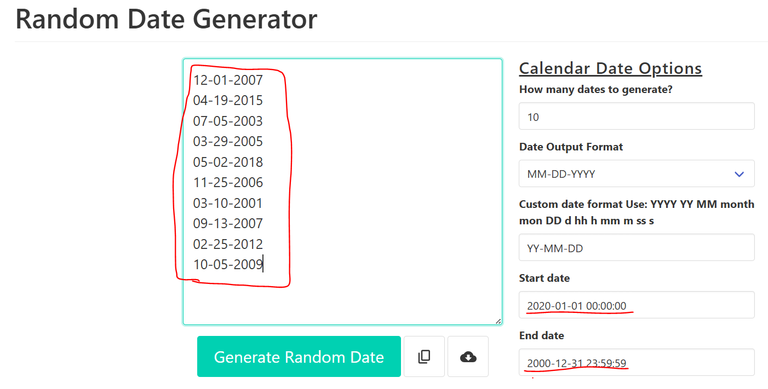
How to Duplicate the error:
- Within an internet browser access the application with the following link Random Date Generator.
- In the “End date” field enter a date preceding the “Start date” field
- Click on the “Generate Random Date” button
Quick Diagnosis:
The logic to check if the start date precedes the end date has likely not been implemented or was improperly implement.
Business Impact:
The application provides dates that do not meet the criteria set by the user and does not inform them of faulty user input provided. The bug undercuts the main feature and intended purpose of the application.

Bug #2: Custom date format parsing issue
Severity: Medium
Summary: Randomly generated dates are mis-formatted when requested under specific user generated custom date formats. The incorrect outputs tend to be provided by random dates with months occurring in the later half of the year from August to December and including March but excluding October.
Evidence:
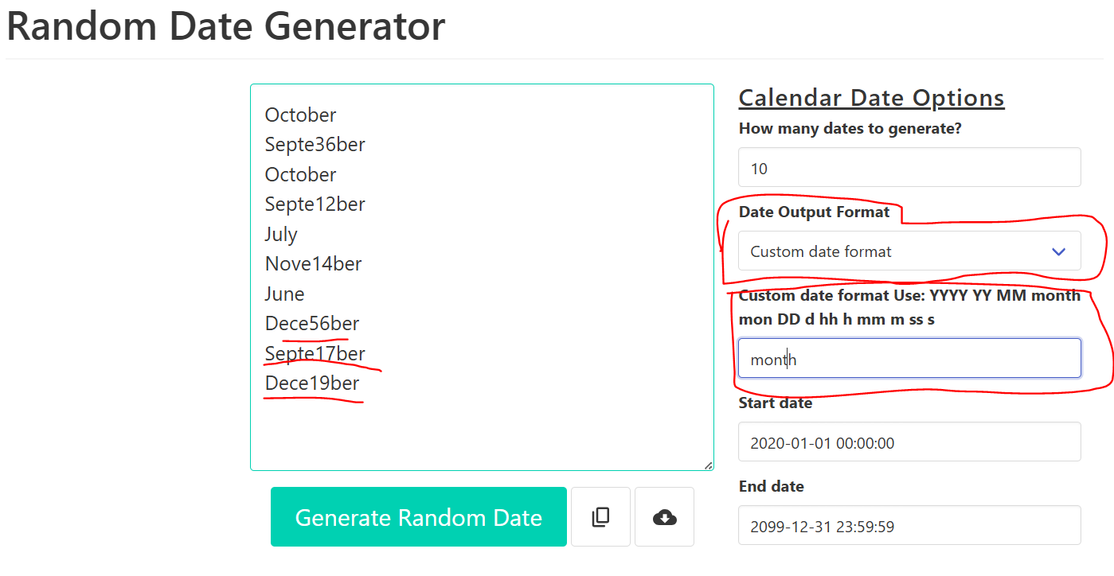
How to Duplicate the bug
- Within an internet browser access the application with the following link Random Date Generator.
- Select the Custom date format option in the “Date Output Format” field.
- Type “month” in the “Custom date format Use: ” field.
- If no mis-formatted dates are provided click “Generate Random Date” until an a mis-formatted date appears.
Quick Diagnosis:
The logic parsing the user input string for “Custom date format Use” is likely faulty and can find multiple substrings in a single string thereby producing multiple values when only one was intended. The
Business Impact:
The ability for users to request random dates with a custom format is impeded. Though likely not used by most users it is a notable feature that many users likely rely upon and improves their user experience.
Bug #3: Overly active date generation
Severity: Low
Summary:
The application will generate new random dates whenever any of the input fields are updated by the user. This behavior will occur even when it is not intended such as when editing the “Custom date format Use:” field when custom date formats are not enabled.
Evidence:
- See the video labeled Bug#3 in the video evidence folder.
How to duplicate the bug:
- Within an internet browser access the application with the following link Random Date Generator.
- Edit the contents of any of the user input fields.
Quick Diagnosis:
The application is likely programmed to produce new outputs whenever any user inputs are altered instead of only providing them when the “Generate Random Date” button is pressed.
Business Impact:
Providing new dates could consume unnecessary computation resources when not being explicitly requested and frustrate users who are typing users input one character at a time.

